
COMET BAY COLLEGE

Physics - Unit 2 - Task 4
Independent Investigation Validation
Name: SOLUTIONS Total Marks /29
Measuring Gravity with a Pendulum
Aim: To calculate a value for gravitational acceleration (g) by examining how the length of the pendulum string (l) affects the period of motion (T) and comparing this with the theoretical equation Galileo hypothesised.

Question 1: Discuss one valid point on the theory you researched about “measuring gravity with a pendulum”. For example, the accuracy of using this method, or the principles behind the theory that makes this experiment an acceptable method of calculating gravity, or any other valid point you discussed in the take home component that relates to the theory behind this method and the requirements to running a pendulum. Use of key scientific words are important. (4 marks)
1 mark – valid theory
2 marks – well explained explanation
1 mark – key scientific words

The reason that the pendulum oscillates about the vertical is that if the pendulum is displaced, the force of gravity pulls down on the pendulum. The pendulum begins to move downward. When the pendulum reaches vertical it can't stop instantaneously. The pendulum continues past the vertical and upward in the opposite direction. The force of gravity slows it down until it eventually stops and begins to fall again. If there is no friction where the pendulum is attached to the ceiling and there is no wind resistance to the motion of the pendulum, this would continue forever.

Because it is the force of gravity that produces the oscillation, one might expect the period of oscillation to differ for differing values of gravity. In particular, if the force of gravity is small, there is less force pulling the pendulum downward, the pendulum moves more slowly toward vertical, and the observed period of oscillation becomes longer. Thus, by measuring the period of oscillation of a pendulum, we can estimate the gravitational force or acceleration.

It can be shown that the period of oscillation of the pendulum, T, is proportional to the pendulum length, l, over the square root of the gravitational acceleration, g.

Question 2: With the method that you ran, was there any procedure that you would change to improve the experiment. This can be based on the research you conducted or the experiment itself. List 2 and explain why. (6 marks)

1 mark each – valid change
2 marks each – well explained explanation
1 mark each – partially explained
- Do not run at horizontal
- g is based on l and T, not m.
- one oscillation is back and forth

Two friends from Year 12, Marty and Tamika, were asked to measure the mass of the Earth using the relationship they had learnt in Year 11 about pendulums and the new formulas they have learnt in Year 12 relating to Einstein’s Gravitational constant. Now Year 11 was a long time ago, so they have approached you to help them. This is the front sheet of their assignment.

Background: The principle behind the pendulum swing and the conical swing of the pendulum are fundamentally the same. They are both completing one revolution in the same time frame, just different paths.

Aim: To find the mass of the Earth using a pendulum

Material:

- 200 g mass
- String and scissors
- Metre rule
- Protractor
- A3 sheet of paper
- Stop watch
- Pair of compasses (draw circles)
- 2 sets of retort stands, bossheads and clamps

Method:
- Draw a circle on the sheet of paper using the pair of compasses. Make the radius of the circle 150 mm and mark clearly the centre. Measure accurately and record the radius in the results section.
- Tie the mass (pendulum’s bob) onto the string and using a permanent marker, mark the string so the length of the pendulum (to the centre of the bob) is 350 mm. Measure the length accurately and record it in the results section.
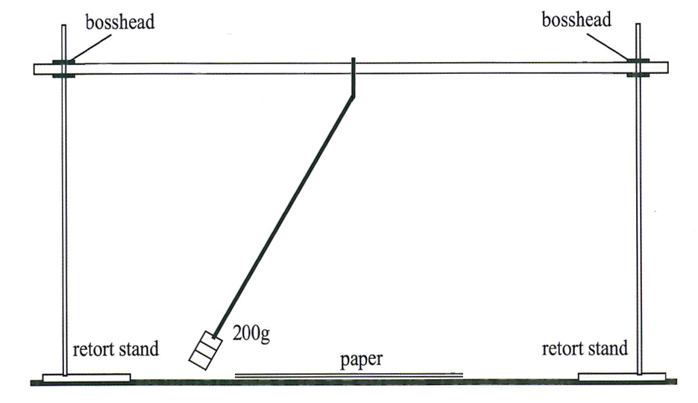
Figure 1: Equipment used to measure the rotation of the pendulum.
- Set up the equipment as shown in Figure 1. Tie the end of the string to the ruler, so the mark on the string is 10 mm below the ruler.
- Hold the string at the knot at the ruler end and with your other hand start the mass moving in a circular path.
- Use your fingers at the knot to maintain the circular motion of the bob, so it follows the path drawn out on the paper.
- Swing the pendulum so that the mass follows the circumference of the circle drawn out on your page as closely as possible.
- Measure the time for 20 complete revolutions.
- Repeat the experiment five to six times and complete Table 1.

Results:
Question 3: Complete the information below
- Complete the data. (1 mark)
150 mm

350 mm

Radius of circle on paper: _________________________________
Length of string: ________________________________________
- Complete the table below (2 marks)
Table 1: The results from the rotation of a pendulum.
Trial | Time for 20 revolutions (s) | Period  (s)
1 | 24.58  1 mark averages  (23.63 s)  1 mark for T  (1.18 s) | -
2 | 22.61 | -  T = 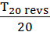  = 1.18 s
3 | 23.51 | -
4 | 24.28 | -
5 | 23.98 | -
6 | 22.82 | -
Ave

Question 4:
Marty and Tamika tell you the equation they have to use is;
g =
where G = 6.67 × 10⁻¹¹ m³ kg⁻¹ s⁻²
r - radius of the Earth (m)
= 6371 km
g - gravity; that needs to be determined using the pendulum method completed in Year 11.

Now you look back at your experiment where you researched and wrote down what the theoretical equation that scientists used to calculate ‘g’, the acceleration due to gravity when using a pendulum. The equation used was: (include what each letter of the equation represents and the units of measurement). (4 marks)
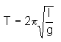 (1 mark)
T - period (s) of a pendulum (1 mark)
l- length (m) of the string (1 mark)
g - acceleration due to gravity (m s⁻²) (1 mark)

Question 5:
Calculate g: (2 marks)
g= 4π² ( L )
T²
g= 4π² ( 0.35 ) (1 mark)
1.18²

T = 1.18 s
L = 0.35 m
g = 9.92 m s⁻² (1 mark)

Question 6:
Now feeling pretty pleased with yourself, you decide to find the mass of the Earth given the information you have obtained from Marty and Tamika. Space below to calculate the mass of the Earth. (If unable to calculate g, use 9.8 m s⁻²) (2 marks)
g =
M = 9.92 x 6371000² (1 mark)
6.67 × 10⁻¹¹
M = 6.04 x 10²⁴ kg (1 mark)

Question 7:
The generally accepted value for the Earth is m = 5.97 × 10²⁴ kg. Calculate the percentage error between the value you obtained and the accepted value. (2 marks)
Percentage Error
%_{error} = Practical result – Theoretical results × 100
Theoretical result

%_{error} = 6.04 x 10²⁴ – 5.97 × 10²⁴ × 100 (1 mark)
5.97 × 10²⁴
%_{error} = 1.17 % (1 mark)

Question 8:
Write a discussion, excluding any reference to a hypothesis or variables, because you did not write one. (6 marks)
- Summary of results (1 mark)
- (including numerical values) (1 mark)
- (including percentage error) (1 mark)

- Discusses 3 variables that created errors. (1 mark each)
- Method of improving/removing errors is clear and does not include vague environmental factors or personal factors
(-1 for every method not mentioned or that is not vague)
____________________________________________________________________________________________________________________________________________________________________________________________________________________________________________________________________________________________________________________________________________________________________________________________________________________________________________________________________________________________________________________________________________________________________________________________________________________________________________________________________________________________________________________________________________________________________________________________________________________________________________________________________________________________________________________________________________________________________________________________________________________________________________________________________________

